**Meaty Meaty Meats**

**Menu**

**Appetizers Main course**

**China Broth Lamb Pye**

**A medicinal broth made of**

**chicken, fruit, roots, & herbs A Lamb Pye is a**

**pie**

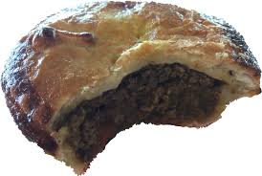

**with a chunky**

**filling of meat and Sauce for a shoulder of Mutton often other savory**

**Ingredients.**

**An oyster sauce for lamb**

**Neats Tongues to**

**Hash A Sauce for a roasted Pullet or Capon a dish of cows'**

**tongues.**

**A wine sauce for poultry**

**Potage of Venison**

**Deserts**

**A venison stew with**

**Apple Cream anchovies and**

**beets.**

**Apples in wine sauce & cream**

**A Shoulder of**

**Mutton**

**Italian Biscuit with Oysters**

**An anise seed & sugar confection Lamb stuffed &**

**served with oysters.**

**Naples Biscuit**

**A dried cookie or biscuit made of sugar & almonds**

